Muhammad Umar Farooq
ST: 9:55, ED: 10:46
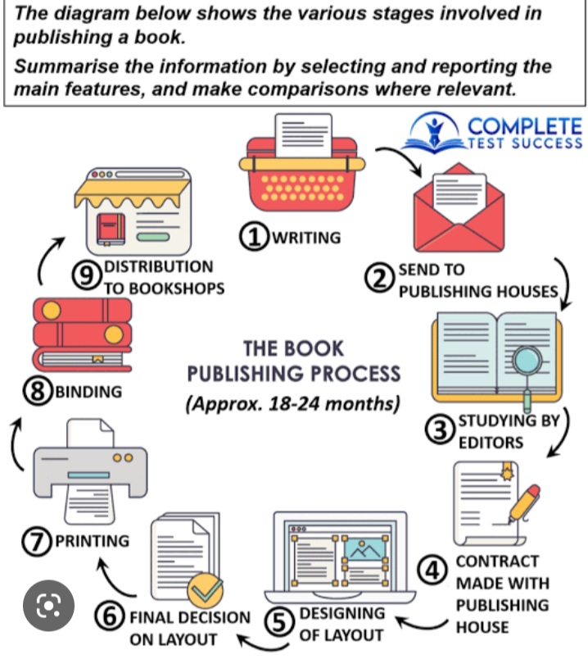
The provided diagram illustrates the multiple stages involved in the process of publishing a book.
Overall, the process begins with writing, and go through some intermediate stages like drafting, printing, binding and ends on distribution to bookshops. Meanwhile, this process took about two years.
Looking at the details, initially operation starts from the writing stage and then send to publishing house. At next, book studied by the editors. After that, the writer made a contract with publishing house which may have some legal and copywrites. Following that, this is the stage which gives a book representation according to their domain, on this point publishing house and writer collaborate design the layout of the book and the cycle then repeats to final decision on layout. In the subsequently stage, book is ready to printing and binding. As result book is distributed to bookshops and ready to rise the light of knowledge and make humanity better.

